NEPAL ENGINEERING COLLEGE
(Affiliated to Pokhara University)

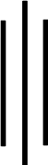

Report on:

LAB 3: POLE-ZERO AND FREQUENCY RESPONSE OF LTI
SYSTEM.

Submitted By: Submitted To:

Name: Aruna Thapa Department Of: CRN: 021-311 Electrical and Electronics
Date: 2082/08/29 Engineering

Objective
In this lab session, we aim to analyze the poles and zeros of various discrete-time systems using MATLAB 7. We also factorize a fourth-order digital filter into cascaded and parallel second- order sections and observe the frequency and phase responses.

Theory:
The poles and zeros of a discrete-time Linear Time-Invariant (LTI) system are fundamental in understanding its behavior. Poles determine the stability and resonant frequencies of the system, while zeros influence the frequency response by attenuating or amplifying specific frequencies. The transfer function of a system, represented as a ratio of polynomials in z−1z^{-1}z−1, reveals these poles and zeros. Factorizing higher-order filters into cascaded or parallel second-order sections simplifies implementation and analysis. The frequency and phase responses characterize the system’s behavior across different input frequencies, essential for applications in signal processing and control systems.

MATLAB Program to calculate and plot the poles and zeros of the digital filter.
% CRN: 021-311 - Pole-Zero Plot using tf2zp and zplane b = [0.2 0.1 -0.3 0.4 0.3];
a = [1 0.4 -0.2 0.3 -0.1];
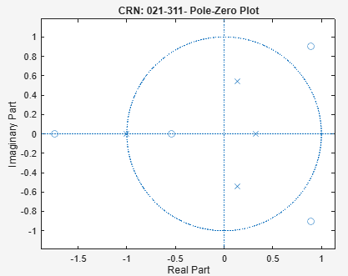
[z, p, k] = tf2zp(b, a); zplane(z, p);
title('CRN: 021-311 - Pole-Zero Plot');

disp('Zeros:'); disp(z);
disp('Poles:'); disp(p);
disp('Gain:'); disp(k); Command Window Output: Zeros:
0.8878 + 0.9050i
0.8878 - 0.9050i
-1.7388 + 0.0000i
-0.5368 + 0.0000i

Poles:
-1.0000 + 0.0000i
0.1390 + 0.5396i
0.1390 - 0.5396i
0.3221 + 0.0000i

Gain:
0.2000

Figure 1: A pole-zero plot for a digital filter derived using MATLAB functions tf2zp and zplane. It visually represents the locations of poles and zeros in the z-plane, helping analyze the filter's stability and frequency response.

MATLAB Program to calculate the transfer function for given poles and zeros.
% CRN: 021-311 - Transfer Function using zp2tf z = [1; -1; 1+1i; 1-1i]; % Zeros
p = [0.5; -0.5; 0.1+0.2i; 0.1-0.2i]; % Poles k = 1;
[b, a] = zp2tf(z, p, k);

disp('Numerator Coefficients (b):'); disp(b); disp('Denominator Coefficients (a):'); disp(a); Command Window Output:
Numerator Coefficients (b):
1 -2 1 2 -2

Denominator Coefficients (a):
Columns 1 through 4

1.0000 -0.2000 -0.2000 0.0500

Column 5

-0.0125

MATLAB Program to plot poles and zeros of accumulator system.
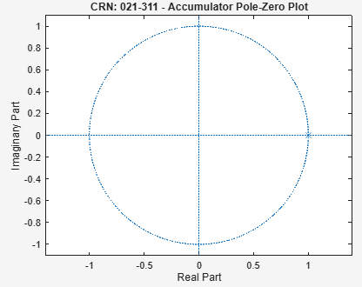
% CRN: 021-311 - Pole-Zero Plot for Accumulator b = 1;
a = [1 -1];
[z, p, k] = tf2zp(b, a); zplane(z, p);
title('CRN: 021-311 - Accumulator Pole-Zero Plot');

disp('Zeros:'); disp(z);
disp('Poles:'); disp(p);
disp('Gain:'); disp(k); Command Window Output: Zeros:
Poles: 1

Gain:
1

Figure 2 Accumulator Pole Zero Plot

Figure 2: A pole-zero plot of an accumulator system, showcasing the system's characteristic with a single pole at z=1. This basic plot reflects the system's integration behavior.

MATLAB Program to factorize the 4th-order filter into two cascaded 2nd-order filters.
% CRN: 021-311 - Cascaded Form using tf2sos z = [1; -1; 1+1i; 1-1i]; % Zeros
p = [0.5; -0.5; 0.1+0.2i; 0.1-0.2i]; % Poles
k = 1;

[b, a] = zp2tf(z, p, k); sos = tf2sos(b, a);
disp('Second Order Sections:'); disp(sos);
Command Window Output:
Second Order Sections:
Columns 1 through 4

1.0000 -0.0000 -1.0000 1.0000
1.0000 -2.0000 2.0000 1.0000

Columns 5 through 6

-0.0000 -0.2500
-0.2000 0.0500

MATLAB Program to perform partial fraction expansion.
% CRN: 021-311 - Partial Fraction Expansion using residuez [z, p, k] = tf2zp(b, a); % ensure b and a already exist
[r, p, f] = residuez(b, a);

disp('Residues:'); disp(r);
disp('Poles:'); disp(p);
disp('Direct Terms:'); disp(f);
Command Window Output:
Residues:
-9.3750 + 0.0000i
-12.1875 + 0.0000i
-68.7187 -26.3437i
-68.7187 +26.3437i

Poles:
0.5000 + 0.0000i
-0.5000 + 0.0000i
0.1000 + 0.2000i
0.1000 - 0.2000i

Direct Terms:
160.000

MATLAB Program to plot frequency and phase response.
% CRN: 021-311 - Frequency and Phase Response clc;
clear;
close all;

% Define zeros, poles, and gain
z = []; % zeros
p = -0.5; % pole
k = 1; % gain

% Convert zero-pole-gain to transfer function
[b, a] = zp2tf(z, p, k);

% Plot frequency and phase response
freqz(b, a);
title('CRN: 021-311 - Frequency and Phase Response');

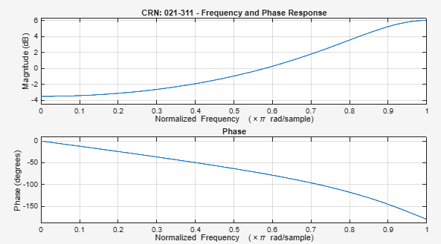

Figure 3 Frequency and Phase Response of the Digital Filter

Figure 3: The frequency and phase response of a digital filter, plotted using MATLAB's freqz function. The graph demonstrates how the filter processes input signals at various frequencies and their phase shifts.

Conclusion
In this lab, we successfully analyzed the poles and zeros of digital filters using MATLAB 7. The filters were factorized into cascaded and parallel forms. We visualized their frequency and phase responses, improving our understanding of LTI system characteristics.

